F-30 -

Functionality
A process for transferring posted items from one Customer’s account to another.

Scenario
The invoice posting was made on an incorrect Customer’s account. You don’t want to post a reversal, so you can make a transfer posting instead.

Requirements
Document (items) posted on Customer’s account.

Menu Path | Accounting → Financial Accounting → Accounts Receivable → Document entry → Other → Intern.transf.psting → F-30 - With clearing
Transaction Code | F-30

1. Double click on F-30 - With clearing.

Post with Clearing: Header Data

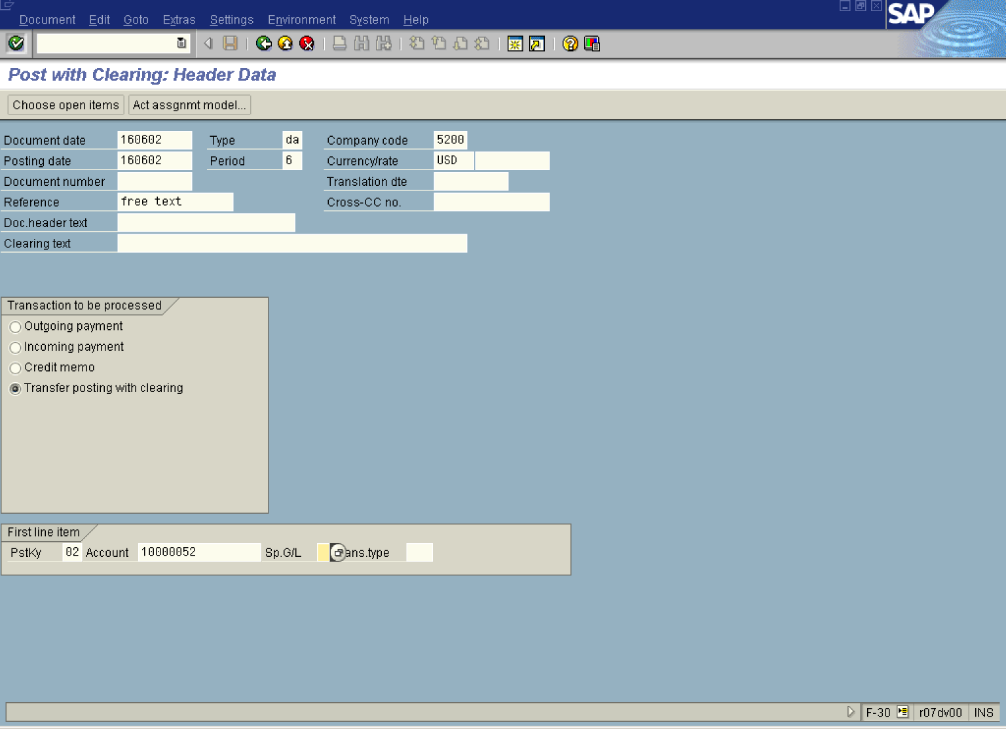

2. Update the following fields:

Field Name | Field Description | Values
Document date | Date the transaction occurred | Example: 160602
Type | Code identifying the document type | Example: DA
Company code | Code identifying a separate legal entity for which a separate set of accounts is maintained for external reporting purposes | Example: 5200
Posting date | Date that the business transaction occurred | Example: 160602
Currency/rate | Code identifying the currency used in the transaction | Example: USD
Reference | Free transaction description | Example: free text
PstKy | Posting key number. Enter the posting key to Debit a customer | Example: 02
Account | Code identifying the Customer account | Example: 10000052

3. Click Enter Button . Now you need to enter an amount of the line item:

Post with Clearing: Add Customer item

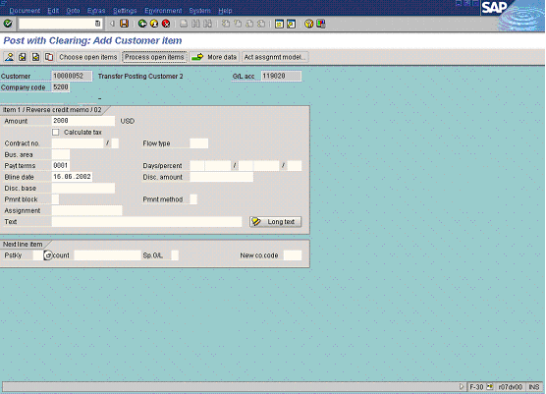

4. Update the following fields:

Field Name | Field Description | Values
Amount | Amount of the line item | Example: 2000

5. You completed posting for Debit side of the document. Now you need to select the open item(s) on the other customer account and clear them both. Click Process open items Button to select open item to be cleared:

Post with Clearing: Select open items

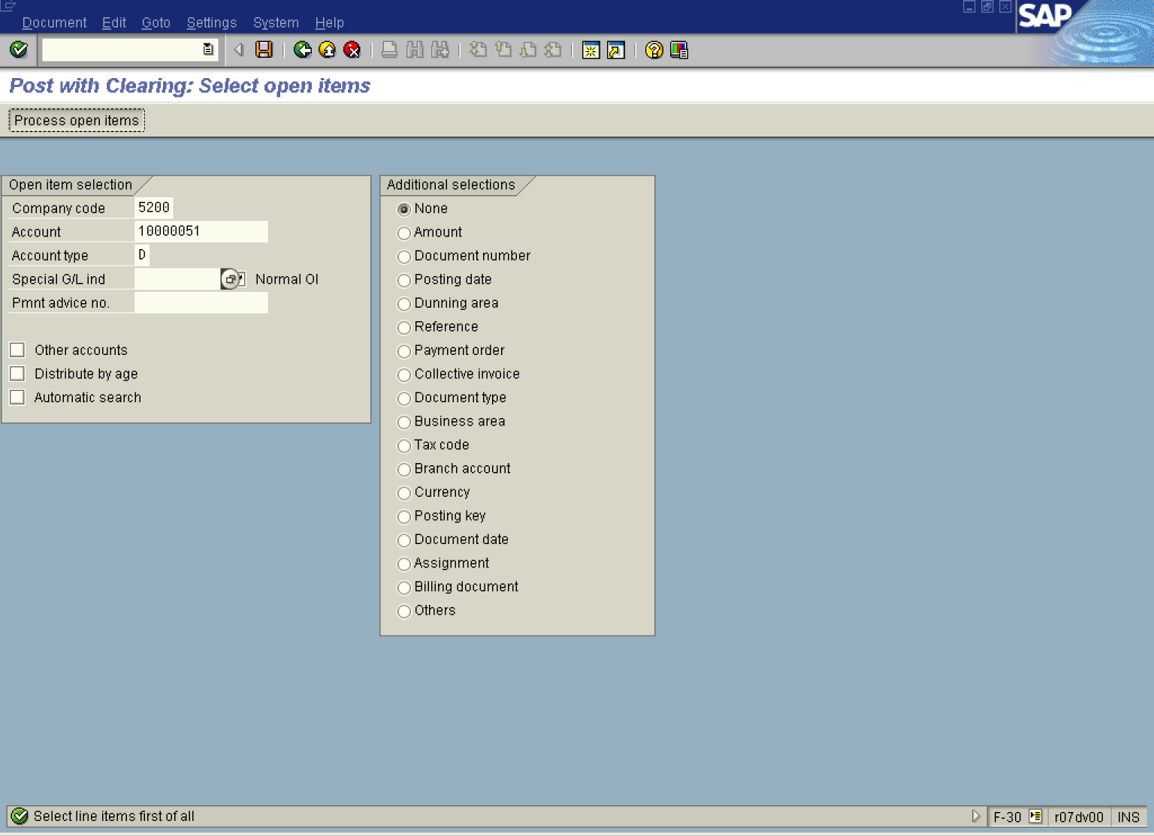

6. Update the following fields:

Field Name | Field Description | Values
Account | Code identifying the Customer account. Enter here the code of the other customer involved in posting | Example: 10000051

7. Now click Process open items Button . The system will display a list of open items to be cleared. Double-click on the document number 180001033 to select it for clearing. The document will be highlighted in blue:

Post with Clearing: Process open items

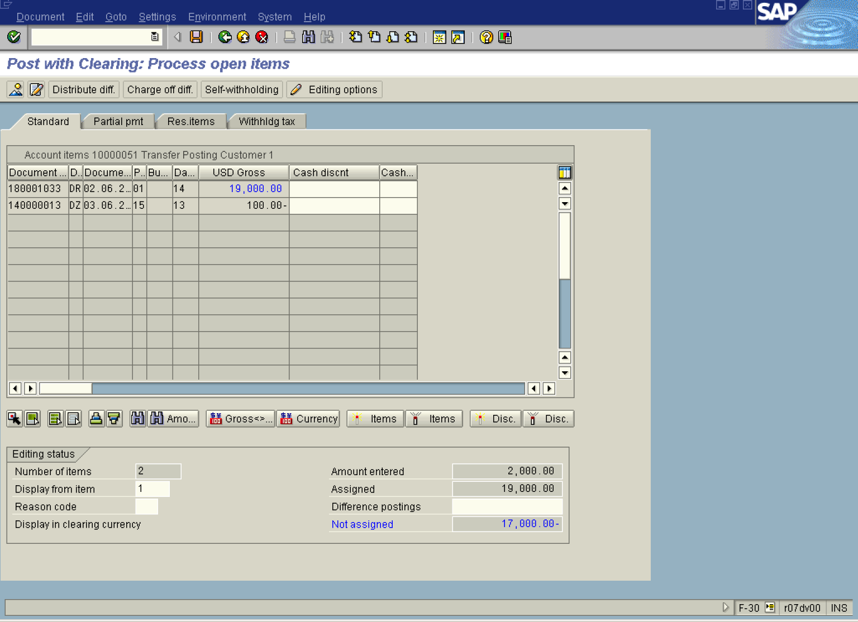

8. A value of the field “Not assigned” is equal 17.000,- USD. This amount is a difference between our posting entered manually (Ct 2.000,-) and selected item to be cleared (Dt 19.000,-). To clear the difference, simply double-click on a field “Difference postings”. The field will be filled-in automatically with the value 17.000, -.
9. You can simulate your document before posting it. Select from menu path Document – Simulate:

Post with Clearing: Display Overview

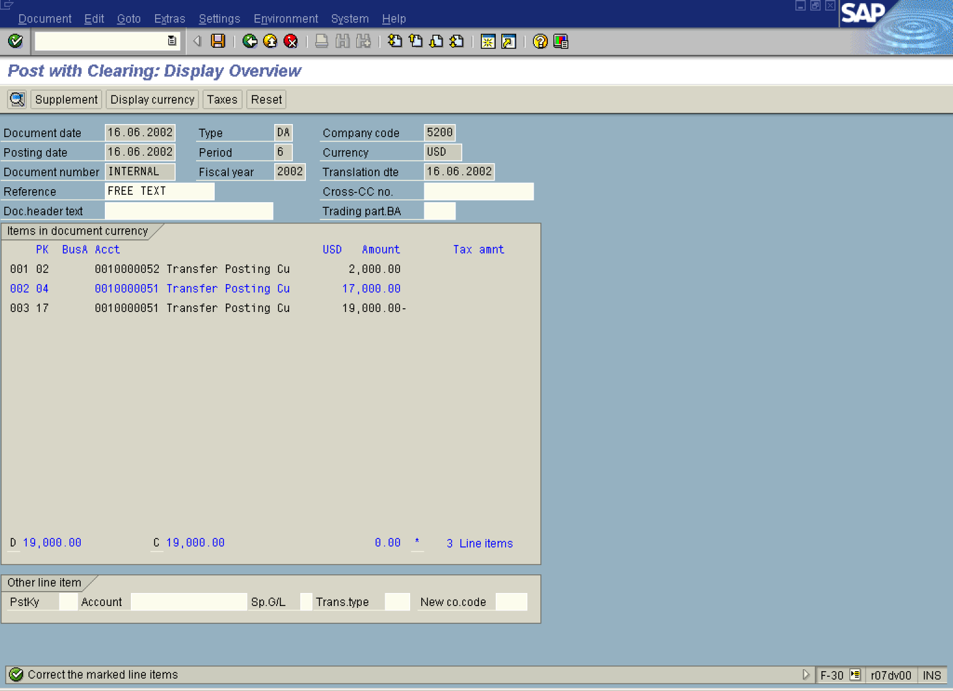

10. One of the items is highlighted in blue – some additional data must be entered. Double-click on this item:

Post with Clearing: Correct Customer item

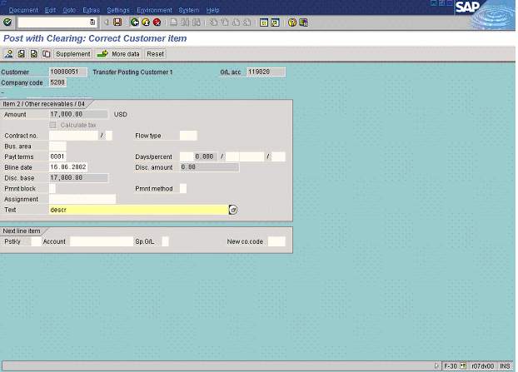

11. Update the following fields:

Field Name | Field Description | Values
Text | Field “Text” is a required entry. You’re going to post a new document on customer account (17.000 = 19.000 – 2.000) and that’s why the system asks you to enter a description of this document. This is a free text field, so you can enter any description here. | Example: descr

12. After entering your description of the line item, press Back Button . As you can see, all the items are now completed (displayed in black colour):

Post with Clearing: Display Overview

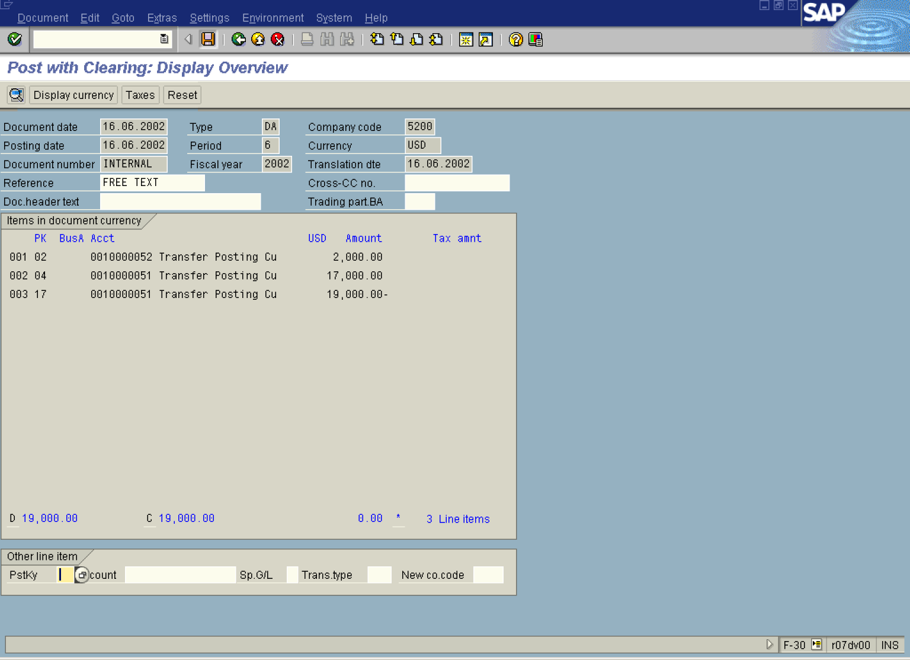
13. You can post your clearing. Click Save Button..
14. The message bar displays “Document 160000029 was posted in company code 5200”.
15. The following postings took place:
- A new document was posted: Dt 2.000,- customer 10000052
- Another new document was posted: DT 17.000,- customer 10000051,
- The amount of 19.000,- was posted on customer account 10000051(Ct side) and cleared with the previously posted document 180001033.

